**Practical-1**

**Aim: WAP to create a class to read and add two distance. (e.g. 8 feet 16 inch + 4 feet 14 inch = 14 feet 6 inch)**

**Program:**

#include<iostream>

using namespace std;

class Converter

{

public:

int feet;

int inch;

};

int main()

{

Converter c1,c2,c3;

cout << "=> Enter feet value of a :- "; cin >> c1.feet;

cout << "=> Enter inch value of a :- "; cin >> c1.inch;

cout << endl << "=> Enter feet value of b :- "; cin >> c2.feet;

cout << "=> Enter inch value of b :- "; cin >> c2.inch;

c3.inch = (c1.inch+c2.inch)%12;

c3.feet = (c1.feet+c2.feet) + ((c1.inch+c2.inch)/12);

cout << endl << "----------------------------" << endl;

cout << endl << "=> Total feet :- " << c3.feet;

cout << endl << "=> Total inch :- " << c3.inch;

return 0;

}

**Output:**

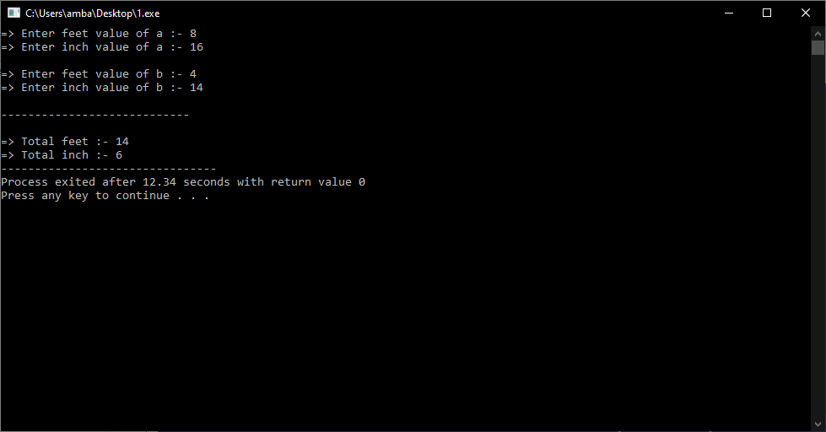

**Practical-2**

**Aim: WAP to create a class to read and add two times.**

**Program:**

#include<iostream>

using namespace std;

class Time

{

public:

int hour;

int min;

int second;

};

int main()

{

Time t1,t2,t3;

cout << "=> Enter hour of a :- "; cin >> t1.hour;

cout << "=> Enter minute of a :- "; cin >> t1.min;

cout << "=> Enter second of a :- "; cin >> t1.second;

cout << endl << "=> Enter hour of b :- "; cin >> t2.hour;

cout << "=> Enter minute of b :- "; cin >> t2.min;

cout << "=> Enter second of b :- "; cin >> t2.second;

t3.second = (t1.second+t2.second)%60;

t3.min = ((t1.min+t2.min)+((t1.second+t2.second)/60))%60;

t3.hour = (t1.hour+t2.hour) + ((t1.min+t2.min)+((t1.second+t2.second)/60))/60;

cout << endl << "----------------------------" << endl;

cout << endl << "=> Total hour :- " << t3.hour;

cout << endl << "=> Total minute :- " << t3.min;

cout << endl << "=> Total second :- " << t3.second;

return 0;

}

**Output:**

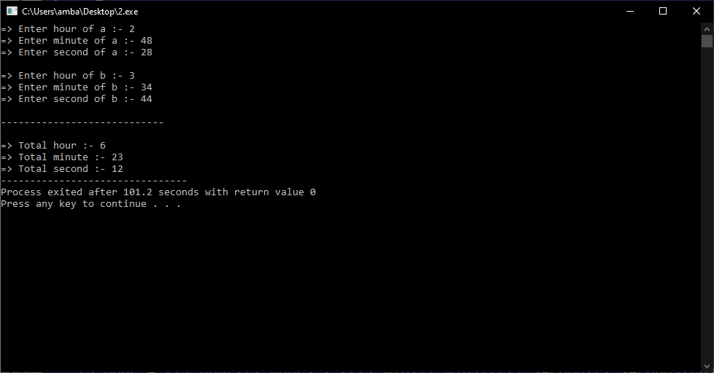

**Practical-3**

**Aim: WAP to create class to read time in seconds and convert into time in (HH:MM:SS) format.**

**Program:**

#include<iostream>

using namespace std;

class Converter

{

public:

int hour;

int min;

int second;

};

int main()

{

Converter t1;

cout << "=> Enter a second :- "; cin >> t1.second;

t1.hour = (t1.second/60)/60;

t1.min = (t1.second/60)%60;

t1.second = t1.second%60;

cout << endl << "-------------------------------------" << endl;

cout << endl << "=> Time in HH:MM:SS format :- ";

cout << t1.hour << " : " << t1.min << " : " << t1.second << endl;

return 0;

}

**Output:**

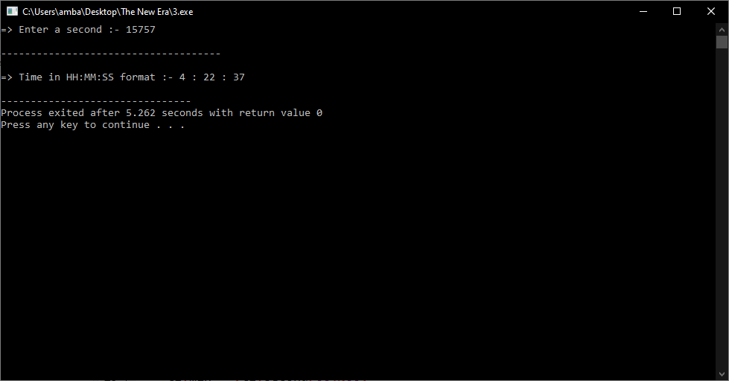

**Practical-4**

**Aim: WAP to create a class which Read and Print House details along with Room details.**

**Program:**

#include<iostream>

using namespace std;

class House

{

public:

int house_number;

int room;

int hall;

int kitchen;

char house_name[100];

};

class Room

{

public:

int length;

int breath;

int height;

};

int main()

{

House h1;

Room r1;

cout << "=> Enter your house number :- "; cin >> h1.house_number;

cout << "=> How many room in your house :- "; cin >> h1.room;

cout << "=> How many hall in your house :- "; cin >> h1.hall;

cout << "=> How many kitchen in your house :- "; cin >> h1.kitchen;

cout << "=> Enter your house name :- "; cin >> h1.house_name;

cout << endl << "=> Enter your room length in feet:- "; cin >> r1.length;

cout << "=> Enter your room breath in feet:- "; cin >> r1.breath;

cout << "=> Enter your room height in feet:- "; cin >> r1.height;

cout << endl << "---------------------------------------------" << endl;

cout << endl << "=> Your house number :- " << h1.house_number << endl;

cout << "=> Total rooms in your house :- " << h1.room << endl;

cout << "=> Total halls in your house :- " << h1.hall << endl;

cout << "=> Total kitchens in your house :- " << h1.kitchen << endl;

cout << "=> Your house name :- " << h1.house_name << endl;

cout << endl << "---------------------------------------------" << endl;

cout << endl << "=> Your room length :- " << r1.length << " feet" << endl;

cout << "=> Your room breath :- " << r1.breath << " feet" << endl;

cout << "=> Your room height :- " << r1.height << " feet" << endl;

return 0;

}

**Output:**

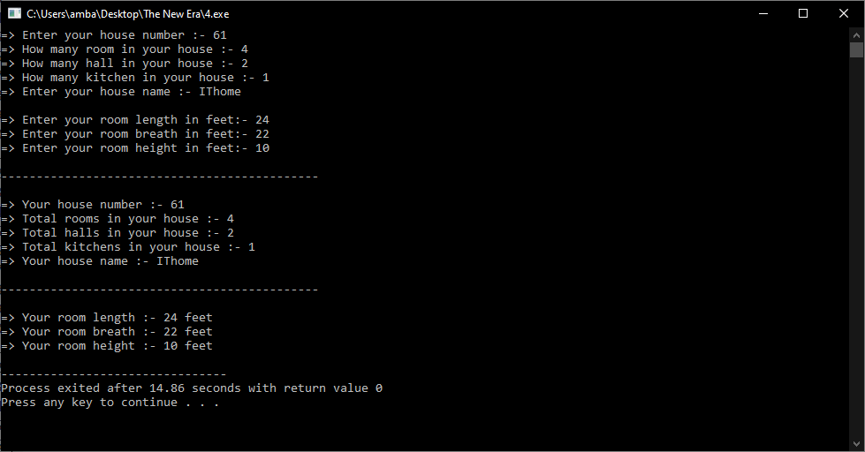

**Practical-5**

**Aim: WAP which illustrates the use of public and private access modifiers.**

**Program:**

#include<iostream>

using namespace std;

class Check

{

private:

int a=1,b=2; // This value is only for run this block.

public:

int c=3,d=4; // This value is only for run every block.

};

int main()

{

Check c1;

/* cout << "=> Value of a :- " << c1.a << endl;

cout << "=> Value of b :- " << c1.b << endl; */

// Can not run this value.

cout << "=> Value of c :- " << c1.c << endl;

cout << "=> Value of d :- " << c1.d << endl;

return 0;

}

**Output:**

